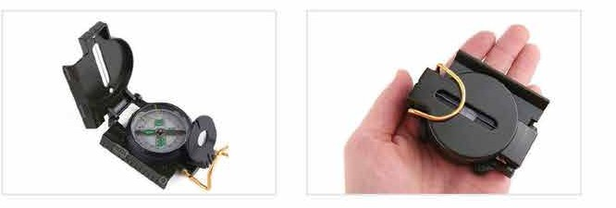

Function
It has Scale of (1:25000) Line map ranging, orientation refers to the north, orientation, slope, azimuth, angle of pitch, mapping ruler, magnifying glass. 1:25,000 scale. Direction symbols contain the luminous material. The upper cover has a conducting line for positioning. The dial is rotatable.
For a more accurate direction finding, the box is filled with liquid damping, so that the magnetic needle is reset as soon as possible, with the function of protecting shock and protecting the shaft tip against wear. With three functions of pointing, positioning and surveying and mapping, it is often used in hunting, exploration, camping and other sports transportation, movement, and is a tool in geology, mining, forestry, survey, irrigation and water conservancy, construction, tourism and other fields. Suitable for field travel to determine the direction and orientation.

Key Features
- It comes with degree, minutes, second and mils which helps navigation easy.
- Meter scale in the edge of compass.
- Illumination in needle with important mark.

Material | : Zinc Alloy
Shape | : Portable
Color | : Dark Green/Olive Green
Dimension (folded) | : 7.5x5.8x2.5cm
Weight | : 79g
Standard | : ISO

